Qui il nome del tuo studio

Scheda di Trattamento Data: __________________

Cognome ______________________________ Nome __________________________________

Difficoltà riferite:__________________________________________________________________

________________________________________________________________________________

________________________________________________________________________________

Altro: __________________________________________________________________________

Note: ___________________________________________________________________________

Cicatrici: ________________________________________________________________________

Situazione dentaria: _______________________________________________________________

Numero orientativo sedute previste: _________ Intervallo di trattamenti stabilito: ____________

Metodo di auricolo-stimolazione, descrizione riassuntiva: ________________________________

________________________________________________________________________________

Sessione Ia: data e note: ____________________________________________________________

________________________________________________________________________________

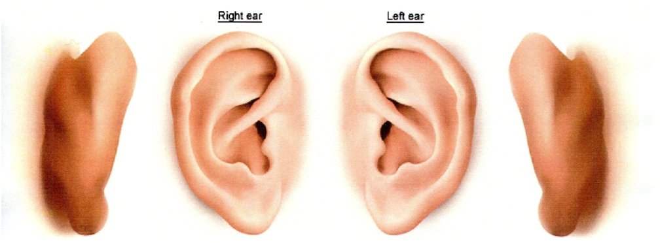
________________________________________________________________________________

Sessioni: data e note: ______________________________________________________________

________________________________________________________________________________

________________________________________________________________________________

Sessioni: data e note: ______________________________________________________________

________________________________________________________________________________

________________________________________________________________________________

